Assignment 0 (CS 747): Building standard classifiers for images

Pankaj Kumar Jatav – G10338769
Goal:
This assignment consists of building, validating, and testing two binary classifiers for a repository of images, namely:
  - A K-nearest neighbor classifier
  - A SVM classifier

Approach:
I followed the below diagram step to solve this assignment.

Pre-Processing of Data:
Below are the steps taken to pre-process that data.
- Standardized to the same size of all the image and converted to 1D vectors. So that each image will have same dimension and same cost function can be applied to all images.
- Save the 1-D Images Vector and Labels to npy file for traning, validation and evaluation files. So that I can avoid preprocessing each time.

Model Training:
For both models I have used the sklearn(machine learning library) python library.

KNN Model Training:
KNN does not require any traning.

SVM Model Traning:
For SVM traing I have used the Linear classifiers(SVM) with stochastic gradient descent from sklearn library(Link)
I used the below values for hyperparameters for svm model and valicated the result.
Epoches = [1, 10, 100, 1000, 10000, 100000, 1000000]
learning Rates = [1, 0.5, 0.1, 0.001, 0.0001, 0.00001, 0.000001]
Regularization constants = [10, 1, 0, 0.1, 0.001 , 0.0001, 0.00001, 0.000001]

Model Selection(Results):
The model selection is done by selecting the best performing model on different hyperparameter on validation data.

K-nearest neighbor- Result:
For K-nearest neighbor Model I have tuned the value of k for odd number between 1 to 99 inclusive. I found that that KNN perform well k is 9.
And below are the results
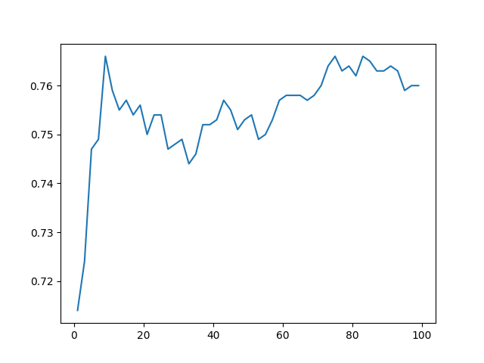

Linear classifiers(SVM) with stochastic gradient descent Results:
For SVM I have tuned the Epochs, Learning rate and Regularization constant for different values. And, model perform well epoches is 1, learning rate is 0.1 and regularization constant is 0.001 and give around 80% of accuray on validation data.
The plot result as below. Also the complete result in text file also avaliabe on Miscellaneous sub-directory. Below plots are the

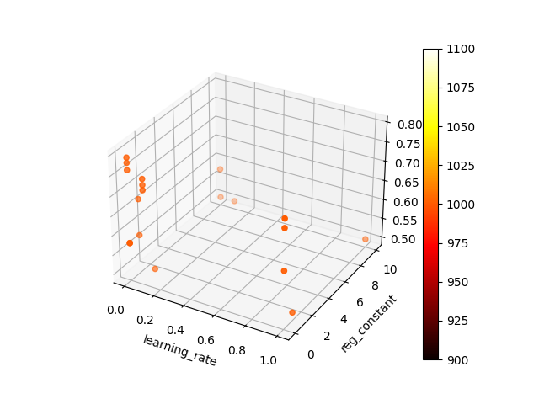
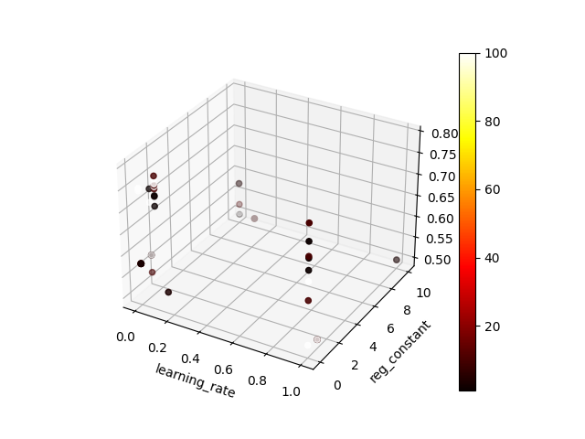

Resuls Comparison:

The SVM perform well on traning as well as on evaluation data.
Below are the comparision using Accuracy and F1 Score on evaluation data.

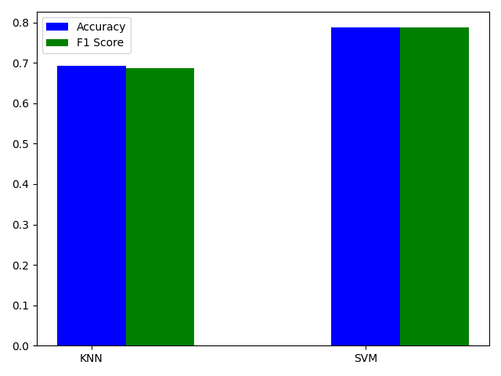

Conclusion:

For KNN when K value is too small the model was not performing well ie it has low bias but as the K- values increased model start performing well. But but when I chose the k very large the performance decrease duo to high bias.

For SVM
1. When the learing rate is too large(learning rate = 10, second column) and Even with the larege epoch the performance does not improve. Which means the Gradient Descent never reacht the local minima.

| 1 | 10 | 10 | 0.5 |
+----------+-----------------+----------------+------------------+
| 1 | 10 | 1 | 0.5 |
+----------+-----------------+----------------+------------------+
| 1000000 | 10 | 10 | 0.5 |
+----------+-----------------+----------------+------------------+
| 1000000 | 10 | 1 | 0.5 |
+----------+-----------------+----------------+------------------+
| 1000000 | 10 | 0 | 0.624 |
+----------+-----------------+----------------+------------------+
| 1000000 | 10 | 0.1 | 0.5 |
+----------+-----------------+----------------+------------------+

2. Even with the large epoch does not guarantee to reach local minima. Can be seen above data.
3. Large Epoch, very small learning rate and very small regularization constant also doest not give best result.
+----------+-----------------+----------------+------------------+
| 1000000 | 1e-06 | 1e-06 | 0.722 |
+----------+-----------------+----------------+------------------+

4. Even with single epoch good performance can achived using good learning rate and good regularization constant value.
+----------+-----------------+----------------+------------------+
| 1 | 0.1 | 0.001 | 0.778 |
+----------+-----------------+----------------+------------------+

